|  |  |  |  |
| --- | --- | --- | --- |
| **Group No.** | **Group Members** | | |
|  | **ID** | **Name** |
| 3 | 1. | 20-42195-1 | LEO, NAFINUR |
| 2. | 20-42752-1 | HOWLADER, MD. SHAKIB |
| 3. | 20-42794-1 | FAHIM, SHAH NAWAJ |
| 4. | 20-42853-1 | RAHMAN, HASIBUR |
| 5. | 20-42870-1 | HASSAN, MD. ALIF |
|  |  |  |

**Laboratory Experiment Report**

Electronic Drives Laboratory

Semester: Spring 2021-22

|  |  |  |
| --- | --- | --- |
| Experiment No. : 04 |  | |
| Experiment Title : Study of zener diode. |  | |
| Date of Experiment: 13-02-2022 | | Date of Report Submission: 16-03-2022 |

**Marking Rubrics for Laboratory Report (to be filled by Faculty)**

|  |  |  |  |  |
| --- | --- | --- | --- | --- |
| **Objectives** | **Unsatisfactory (1)** | **Good (2-3)** | **Excellent (4-5)** | **Marks** |
| **Theory** | The relevant theories are not being described properly. | Part of the relevant theories are described with proper mathematical expression and circuit diagrams (if any) | All the relevant theories are included with proper descriptions, mathematical expressions and circuit diagrams. (if any) |  |
| **Simulation circuits & Results** | Simulation circuits are not included in this report. | Partial simulation circuit results are included in this report. | All the simulation circuits are included in this report with appropriate results. |  |
| **Report Question, Discussion on Comparison between theoretical and simulation results** | Cannot reach meaningful conclusions from experimental data; Cannot summarize or compare findings to expected results | Can extract most of the accurate data. Answers to the report questions are partially correct; Summarize finding in an incomplete way | Can extract all relevant conclusion with appropriate answer to the report questions; Summarize finding in a complete & specific way |  |
| **Organization of the report** | Report is not prepared as per the instruction. | Report is organized despite of few missing sections as per the recommended structure. | Report is very well organized. |  |
| **Comments** | Assessed by (Name, Sign, and Date) | | Total (out of 20): |  |

**(1) Experiment title:** Study of Study of Zener Diode

**(2) Objective of this experiment:**

The main objective of this experiment is to

1. Study the voltage-current characteristics of Zener diode and

2. Observe the voltage regulation characteristics of a Zener Diode.

**(3) Relevant Theory:**

The basic function of Zener diode is to maintain a specific voltage across its terminals within given limits of line or load change. Typically it is used for providing a stable reference voltage for use in power supplies and other equipment. A Zener diode is much like a normal diode, the exception being is that it is placed in the circuit in reverse bias and operates in reverse breakdown. This typical characteristic curve illustrates the operating range for a Zener. Note that its forward characteristics are just like a normal diode. The doping process determines the Zener diode’s breakdown characteristics. Low voltage Zeners less than 5V operate in the Zener breakdown range. Those designed to operate more than 5 V operate mostly in avalanche breakdown range. Zeners are available with voltage breakdowns of 1.8 V to 200 V.

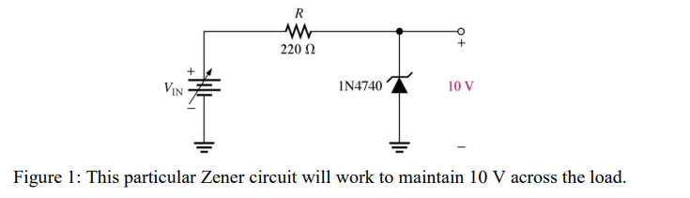

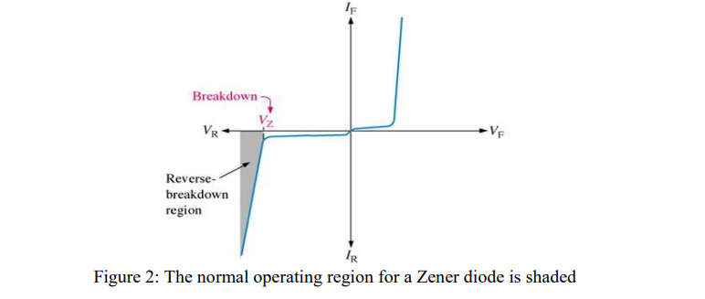

**Apparatus:**

• NI Multisim 14.2

• DC Voltage source

• Zener Diode

• Resistors

• Multimeter

**(4) Simulation circuits and Results:**

Circuit1:

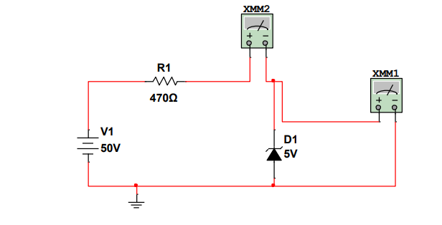

Circuit2:

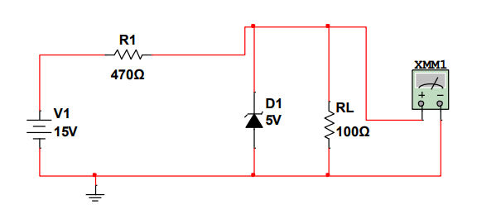

Circuit3:

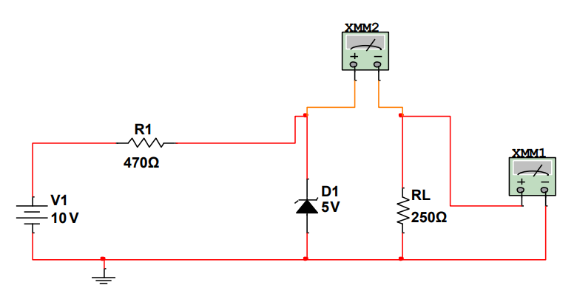

Table:1

|  |  |  |  |
| --- | --- | --- | --- |
| V | Vri | Vz | I |
| 0 | 0 | 0 | 0 |
| 1 | 0.01 | 0.99 | 0.01 |
| 2 | 0.01 | 1.99 | 0.005 |
| 3 | 0.01 | 2.99 | 0.003 |
| 4 | 0.01 | 3.99 | 0.0025 |
| 5 | 0.002 | 4.99 | 0.00004 |
| 6 | 0.003 | 5.99 | 0.00005 |
| 7 | 0.003 | 6.99 | 0.00004 |
| 8 | 0.004 | 7.99 | 0.00004 |

Table:2

|  |  |  |  |  |
| --- | --- | --- | --- | --- |
| Vr | 100 | 300 | 500 | 700 |
| VL | 9.798 | 9.435 | 9.101 | 9.74 |
| IL | 0.20 | 0.63 | 1.05 | 1.48 |

Table:3

|  |  |  |  |  |
| --- | --- | --- | --- | --- |
| V | 16 | 12 | 9 | 6 |
| Vr | 6.05 | 2.06 | 0.68 | 0.5 |
| VL | 8.74 | 8.71 | 7.264 | 4.87 |

**(5) Report Question:**

In case of forward bias, we know Zener diode only permit current to flow in reverse bias mode when the voltage is above a certain value known as breakdown voltage. So the values are negative.

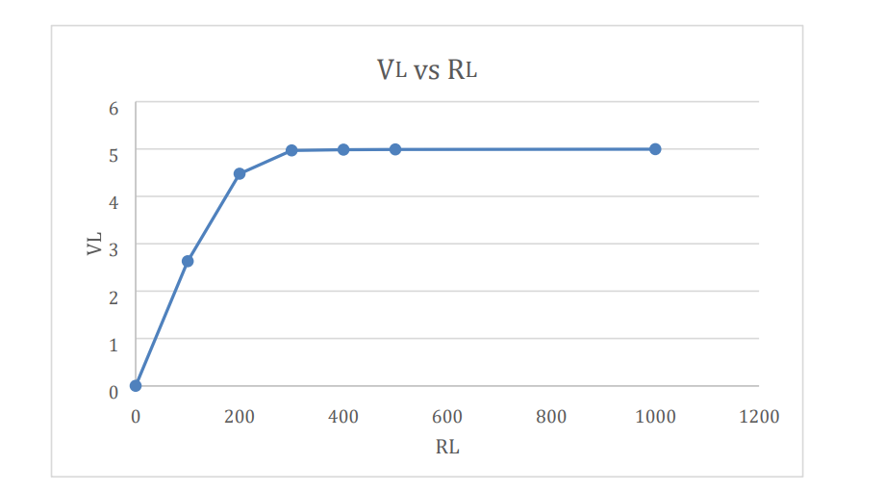

**(6) Discussion:**

In this experiment, we became familiar with Zener diode. The basic function of Zener diode is to maintain a specific voltage across its terminal within given limits of load. For the first circuit diagram, we have measured voltage across resistor and voltage across Zener diode. In the second circuit diagram, we came to know about Zener region and Zener voltage and we measured Zener maximum current. Lastly on our third diagram we took load resistance as constant and calculated load voltage and load current.

**(7) References:**

1. Adel S. Sedra, Kennth C. Smith, “Microelectronic Circuits”, Saunders College Publishing, 3rd ed., ISBN: 0-03-051648-X, 1991

2. David J. Comer, Donald T. Comer, Fundamentals of Electronic Circuit Design, John Wiley & Sons Canada, Ltd.; ISBN: 0471410160, 2002. 3. American International University–Bangladesh (AIUB) Electronic Devices Lab Manual.